# Project Exam 1

Marie Lowzow Morland

<https://innovation-coach.netlify.app/>

<https://github.com/Noroff-FEU-Assignments/project-exam-1-MarieLowzowMorland>

Words: 10243

Summary

This report will go through the process and reflections I made while making a blog. The blog is a student project where I will show my abilities to create a user-oriented product by user testing and applying the knowledge I have gained over a school year. This report will explain how the design has been developed and what the main obstacles were, as well as the solutions I implemented and the thoughts behind them. The main focus is the responses on the user tests, and how these valuable feedbacks found problems with the site and led to an improved user experience in the end. The task description we have been given has had a part with mandatory requirements, and a part with optional extra tasks. Some of these extra tasks have been tackled, but instead of completing all the optional tasks, I have in this project chosen to go deeper into accessibility and WCAG. Not just because the site should be legal, but to create a good user experience regardless of any disabilities. In order to strive for a perfect site in terms of accessibility, I have had to acquire more knowledge in the field, gain a user understanding of user groups with user experiences that are very different from my own and acquire new users for testing.

Innholdsfortegnelse

Project Exam 1 1

Summary 2

Introduction 5

Process 5

Design and technology foundation 6

Initial Design 6

Buttons and shapes: 7

Pictures: 7

Fonts: 7

Wordpress og serveroppsett 7

XD prototype - The band aid: 8

First web version 8

Folder structure 8

CSS structure 9

JS structure 9

*Pages* 9

Feedback 9

API-calls 9

Contact form 10

Search 11

Carousel 11

Modal 12

Loader 12

User feedback 12

Who and how 12

Design changes 12

Colors 13

Navigation and Layout 14

HotJar 14

Findings and solutions 15

Theme change 15

Colors 15

Contact form verbose 16

Redesign dom order (search in top, showing previous search) 17

Empty state (no search hit) 17

Don’t repeat first post in carousel 17

Post summary on each post on top (user didn’t find search keywords) 17

Post layout on mobile 17

Accessibility 17

Why all the effort 17

Testing 18

Testing with users 18

Testing with tools 19

Engaging a facebook forum 19

Findings and solutions 20

Skiplinks 20

«Reduced motion» (not impl yet) 20

Long anchor-tags 20

Colors 21

Aria-current 21

Aria-labels 21

Aria-live (carousel and contact form) 21

Menu close after list (not implemented yet?)) 21

Modal should not tab outside, and be keyboard accessible 21

HTML structure 22

Alt-text 22

Headings 22

Custom focus 22

Last round of feedback 23

Some new fresh eyes on the site 23

Test with a blind user 23

Future work 25

Conclution 25

Key learnings 26

User Testing 26

Technical solutions 26

Accessibility 26

Referance: 28

Accessibility 28

Bugs and function 29

Pictures: 29

Introduction

The task is to put into practice the skills learned over my first year of studies while creating a blog site. The task starts with the development of the design, the use of adobe XD to create a prototype of the website. Furthermore, I have set up WordPress on my web host and added blogs on the admin panel. In this way, the content for my website is stored on WordPress and used as a Headless CMS. The website is built using HTML, CSS and JavaScript, and by making a call to the WordPress REST API to fetch data. The end result is displayed through a GitHub repo, deployed to Netlify. Along the way, the page will be tested by users and be adjusted based on their feedback. This report will cover the process I have had during the project, choices around design and technology, how user feedback has contributed to a better user experience on the site, and how I have strived to create a good site in terms of accessibility. At the end of the report, I will discuss the challenges and questions that have arisen along the way.

# Process

The topic I have chosen for my blog is innovation and entrepreneurship as I teach in the subject on the university and have earlier considered to write a book on the subject. I already had some self-made illustrations that I use in my teaching that would be nice to use. This and the assignment description from Noroff form the base for this project and this report.

The first week I started looking at blogs, searching for pintrest, and looking at websites for inspiration. I used this to make a design and a prototype for the page. As I had trouble finding good pictures for my first concept, I made big changes in the design already during the first week. On Sunday one prototype was made for mobile and one for desktop. These were sent to a test group of 5 people on messenger to get feedback. In the meantime, while waiting for the response, I set up github repo, netlify and wordpress. I also started setting up the folder and file structure for the page in Visual studio.

After chatting and discussing with my test users, I landed a good layout landed navigation and layout on the content that evening. While the design still had a lot to go on when it came to colors, mood, main image and other small details. Still, I now had enough to go on to start coding, creating content for WordPress and creating the functionality that was required in the task. I worked on building the site and the functionality and had the big things in place on May 8th. Every time before I have committed code, I have tested the code with Wave and Google Lighthouse continuously. This has ensured that I have picked up errors in the code relatively early. On the other hand, it has also led to me coming across something else in the code along the way. This has meant that each commit can consist of several quite different changes. I must admit that I also get a little carried away and forget that I have not committed yet. Although you can easily divide file changes into different commits afterwards, it is worse if you have visited the same file for two different reasons, and not worth the effort to divide. Therefore, the various changes are described in github as bullet points. If I had worked with others on the same code in github, this is probably a habit I should put down.

The times I was stuck with a task or just needed a break, I looked at alternative designs and sketched in Adobe XD. May 9, I implemented a new design. A lot of the design procces this day went back and forth from Adobe XD, chrome devops, and Visual studio. I was also chatting with test users and sending them quick screenshots of sketches made in Adobe to get their opinion before I coded the changes.

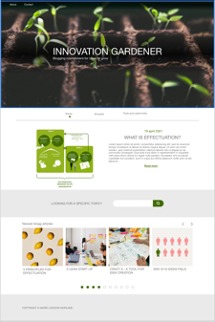 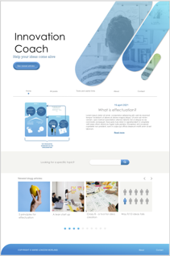 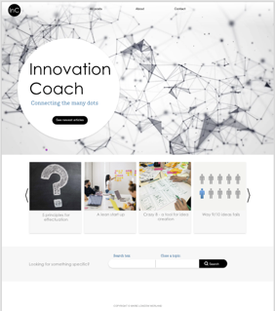 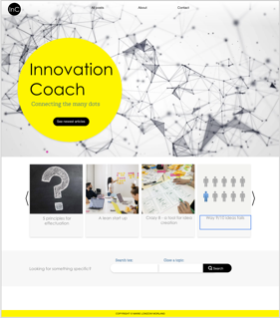 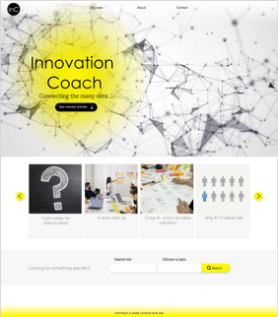

*Some screenshots of the design prosses I went through*

At this point in the project, the focus shifted to obtaining feedback and implementing changes based on them. I installed Hotjar on the site, and got new test users to look at the project with fresh eyes. I also spent time fixing bugs and learning more about accessibility. I have also used e.g. the time I have spent going to and from kindergarten to listen to podcasts about accessibility.

To pick up ideas, feedback and tips wherever I was, I used notes on the phone with checkboxes to make sure I remembered to do something with the points, and that the points could still stand as notes until I wrote this report after they had been checked.

Design and technology foundation

During this project, I have been through several design concepts, and I have never been afraid to make changes. I have tried to have an agile approach to the task and to co create the page with my users by inviting them to join the design discussion. We started to discuss what associations we have to innovation and entrepreneurship. Later I asked them what they thought about shapes, colors buttons, pictures, and navigation and function. Adobe XD has been used both as a tool to create icons and svg-files used directly on the website, to create a prototype to test navigation and content, and as a tool to sketch and illustrate ideas.

## Initial Design

My first concept was based on a metaphor that is widely used in the professional community: the idea is a seed that needs nourishment and care to grow and become something big. I named the blog Innovation Gardener and had an idea for a green color theme with images that played on the metaphor. Although I think the idea is good, I went away from it as it was perhaps a little unclear what the page was about for someone who is not familiar with the jargon. In addition, it was difficult to find good photos that covered the topic. When I tested the prototype on users, I was suggested that the CTA button should go to the about page. I took this as a clear signal that it did not come out well enough what the blog was actually about.

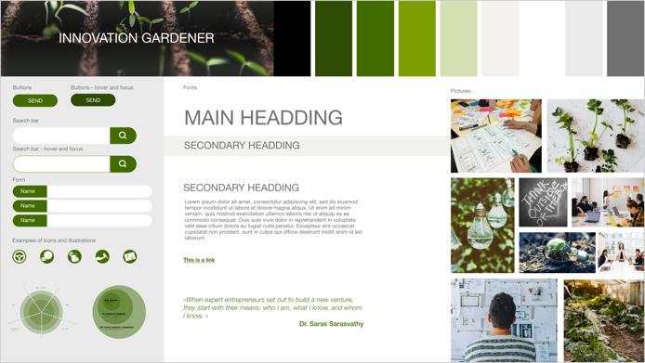 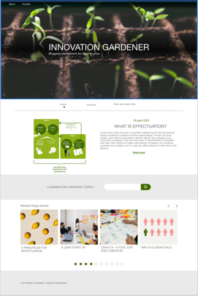

*Style tile and design of home-page*

### Buttons and shapes:

Since I already had a number of illustrations, I had a basis for a design language for the page. The illustrations have round shapes and edges, and therefore it was natural that the buttons should be rounded. Labels, background for icons, input fields and search fields are shaped in the same way.

### Pictures:

The pictures are picked to match the headings and topics for the blog articles. Some of them illustrate different tools and methods that is naturally to explain in the text. Others are mainly decorative and evocative.

### Fonts:

I imagine that some of the posts on the blog can quickly become quite long to cover a topic well enough. The paragraphs are therefore written in the usual helvetica font which is a good font to read on digital surfaces. The headlines are in century gothic which is also a san seriff font. The difference is that the letters are more circular in shape. The letter O, for example, is completely round. This speaks to the circles in the illustrations.

## Wordpress og serveroppsett

After I gave some users the link to my XD prototype, I started to set up Wordpress on my .one web server. Since we had just had an assignment on how to set up Wordpress as a headless CMS, this process was fresh in mind. I added my installation files to a new folder called “innovation-coach-admin”, and installed plain Wordpress and a plugin called “Headless Mode” that I used earlier. With a small change in wp-config, I now could redirect people to my own netlify-site if they visit the Wordpress site, with two exceptions: I can still log in to manage content in Wordpress admin tool, and the API url still goes to Wordpress. For this assignment, I read through the Wordpress API endpoints, and found the standard API to be sufficient for the level 1 tasks and did not need to add any php functions.

During this process I also made an initial commit to GitHub that said, “Hello exam!”, and connected the GitHub repository to a Netlify-site just to see that all the “wiring” worked.

## XD prototype - The band aid:

In a new attempt to create a design concept, I used the shape of my buttons to create my own cover illustration. I picked blue as a color to give associations to technology, professionality and trustworthy.

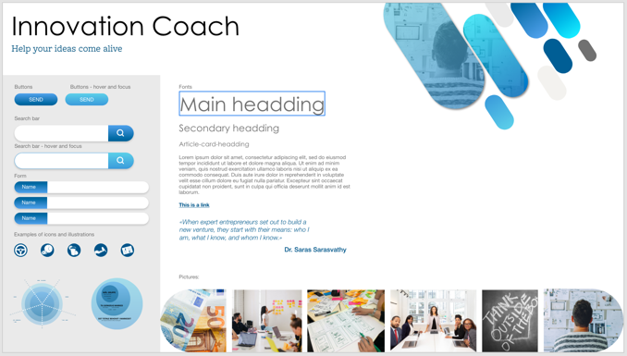 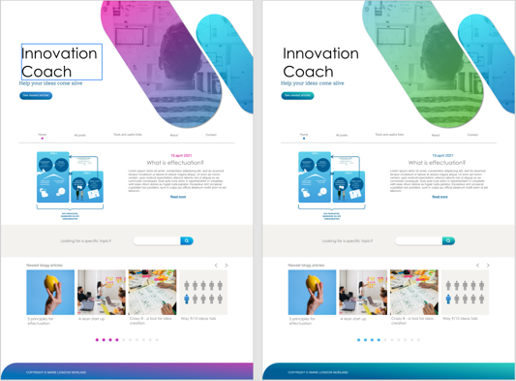

*Style tile and design of home-page*

This Feedback from two of the test users was that the site gave associations about health-related activities. On the one hand, a health-related company should give the feeling of competence, security, trust, professional and science. It is not very different from some associations I also want to give. On the other hand, this is not health-related. Now it should be said that both of these two users work as nurses and may be a little colored by their jobs. But after they said that the shape of the main illustration resembled a band aid, I could not see anything else myself. In conversations it emerged that they not only wanted more colors but first and foremost something that conveyed a creativity and innovation. Preferably something that surprises and challenges.

At the same time, it was mentioned that the use of white space was good and that the page was easy to read. One of the users was disappointed that the posts contained mostly "lorem ipsum" and had become curious about the content. That told me that I in this design have been able to visually convey the content of the blog in a greater extent than in my last attempt. The test also showed that the navigation on the blog worked well, and the users felt they got a good overview of the content. The dot under the menu choices as a mark of which page you are on, was very well liked by the users and is an idea has been included in the end result together with the overall structure

# First web version

## Folder structure

My folder structure is a result of how my earlier projects have been. I try to have my HTML-pages on the root level, then I have a corresponding css and js file located in css/pages/ and js/pages/, respectively. These are the files referenced directly from the HTML-page, and other css files and js files are imported as needed in order to keep my HTML tidy and have a single entrance point for styles and scripts. I.e: The HTML file “about.html” has a corresponding “css/pages/about.css” and “js/pages/about.js”.

CSS structure

I have a hierarchy where files located in “common” are imported first, then “components”, then “templates” and lastly the rules in the page-specific css file itself. I found this a good way to make the cascading part of CSS prefer the most page-specific rules. Also, I found that I personally used a lot less time to find a set of rules when I used multiple files rather than long ones.

JS structure

Templates

This folder house js-files that primarily contains HTML-templates, in my case the header, footer and SVG icons. This is repeating pieces of HTML that are the same for multiple pages. Instead of copy-pasting the HTML into each page, I found that I prefer to use a template that I insert with JS. Thus, changes made to this page is instantly reflected in each page with no risk of forgetting one.

#### Pages

As mentioned above, each HTML-file has a corresponding js-file that import and trigger other pieces of code like the template for the header. In addition, they house logic and page-specific rules that doesn’t repeat across other pages.

#### Components

These are pieces of code that have some logic tied to them, and possibly some HTML as well. They are separated from the page-specific code mainly because they:

* Repeats across multiple pages, such as the searchbar
* Contains a piece of code that has a concrete function that could be easily separated and potentially used somewhere else, i.e the modal

The latter reason is somewhat related to my preference to rather have multiple files with a name describing their purpose than to have longer files.

#### Data

This folder only contains the code for communication with WordPress API, so that my other files does not need to “know how” the API works.

### Feedback

I have not look for people who can give me feedback on the code in the same way I have looked for users to test the user experience, but I got a nice message from a fellow student who was inspired after I posted the page min on discord

## API-calls

In previous assignments, we had never encountered the standard WordPress API for reading posts. Yet reading the about possible arguments from <https://morlanddesign.one/innovation-coach-admin/wp-json/> gave me the information I needed to paginate, search and to filter on categories. In addition, fellow students mentioned the “_embed” flag that were not listed on the endpoint, yet made WordPress embed i.e., information about featured images, which saved me from having to follow two levels of link originally included in the response.

In addition, I later noticed two response headers “x-wp-totalpages” and “x-wp-total” when I inspected the network calls in google devtools. I ended up using the former to remove the “more posts”-button when I had fetched the last page, instead of my first approach where users could press it until the result was empty.

## Contact form

I reused my own “formValidation.js” from two earlier assignments, and once again had to make some adjustments. First, I moved user notification logic to a file of its own since several imports in my previous assignment included formValidation just to use the notification part.

Later on, when I did a lot of visual improvements and fixed accessibility, I also added a step to my component that rewrote the form HTML around input elements so that I did not have to write repeating code to add i.e. error-message divs. An example is showed below:

|  |  |
| --- | --- |
| Code in HTML | <div>  <label for="fullname">  Full name <span class="requirement"> (More than 5 characters) </span>  </label>  <input  type="text"  name="fullname"  id="fullname"  required  data-minlength="6"  />  </div> |
| Resulting HTML | <div>  <label for="fullname">  Full name <span class="requirement">(More than 5 characters)</span>  </label>  <div class="input-wrapper">  <input  type="text"  name="fullname"  id="fullname"  required=""  data-minlength="6"  aria-describedby="fullname-error">  <div class="field-icon">  <button aria-label="Toggle visual error message." class="error-info-toggle">  <svg xmlns="http://www.w3.org/2000/svg" width="36" height="36" viewBox="0 0 36 36">  ...  </svg>  </button>  <div aria-label="Field valid." class="field-valid-icon">  <svg xmlns="http://www.w3.org/2000/svg" width="25.331" height="30.61" viewBox="0 0 25.331 30.61">  ...  </svg>  </div>  </div>  <div id="fullname-error" class="form-error"></div>  </div>  </div> |

As you can see, the amount of HTML now needed to write manually is centred around the label text and input rules, while the form script adds what is needed to style and function properly. The functionality changes are further discussed in the accessibility section.

## Search

## Carousel

Thankfully, I had made a carousel on the previous project and many of the challenges had already been figured out. Much of the code and principles could be reused, which was very time saving.

The main idea was to remember the index of the element I wanted to stay in the center, and then increase or decrease this index based on what the user clicked on. This time, however, the index is added to the start on the left. Because I use *“beforeend”* to retrieve html for the posts, I get the posts in chronological order. I enter "new posts" each time the button is pressed to advance in the carousel. Thus, you will not be able to err through all the entries but must activate the button to get to the next entries in the list. The advantage of this is that if you are not so interested in the carousel and for some reason want to read the footer (not that it is so interesting, but in principle), then you must not tab through everything the carousel contains. On the other hand, it was annoying that you now had to tab back every time you pressed the button. To make it easier for a screen reader user to get an overview of the new content in the carousel without having to tab back all the time, I therefore added an aria-live attribute to the carousel content so that it is read out without the user having to change focus away from the button.

I let javascript calculate how many posts there is room in the carousel. At the end of the code, I have added that in the resized window you check again how many posts there is room in the carousel, before you possibly download the posts again. This way I handle responsiveness but avoid downloading posts unnecessarily

## Modal

The modal was a technique that I thought would be a lot of work to implement, yet proved quite straight-forward. In an earlier project, I had experimented whit an shopping cart overlay. For this exam I could use the same concept with an overlay that spans the entire screen, where the modal is placed in the centre. It turned out the js-part in my implementation more or less just added the HTML-element to the DOM and removed it again when it should be closed.

After listening to a podcast called “Universellt utformet”, I discovered that this version was a bit too simple, and had to revisit it later in order to make sure that the user cannot use the keyboard to focus elements outside the modal window, nor let screen readers read the content behind the modal.

## Loader

The loader is designed as two dots with a line that moves back and forth and where the dots grow as they get connect. The loader is meant to be a small abstract illustration of the slogan on the homepage: “Helping you connecting the dots”. The idea came first, and the loader is a typical example of where the author of this report severely overrated her own prowess with css as several hours went into understanding animations and making the animation work in a fluid manner.

User feedback:

Who and how

To test my blog site and ensure a user-friendly product, I´ve tested with different types of people and done both quantitative and qualitative methods to collect user data. I started with user testing the first week to test the design, and continued testing as I coded the page.

Even though I learned a lot, and did changes backed by information about user behavior for Hotjar, user Interviews were my main source of valuable information once again. I started with 5 different users to test the page while answering questions and tell me their honest opinion on different aspects. They have tested the page several times during the whole process, while I later in the process, asked more people to do me the favor. It has been valuable to test the page with new people to get some fresh eyes on the project.

## Design changes

While trying to come up with an innovative design for a blog (What a goal for a beginner in web design!) I searched the web for inspiration. <https://meshcommunity.com/> became my main inspiration. I think the page was aesthetically beautiful and the animation / video on the front page gave an abstract illustration of development, process and movement. After looking in the code for the page (which is not very exemplary in terms of tidiness or accessibility) I saw that this might not be so difficult to achieve myself. Maybe something like that could be the extra creativity factor my website was missing? When I found a video on pixabay that could serve as a calm background and that could in an abstract way illustrate some aspects of an entrepreneurial process, this provided a new solgan for the blog: “Helping you connect the dots” Drawing lines between dots is also the though behind the loader. A dot got to shape the logo as well, and I realized that I now had a dot-theme for my design.

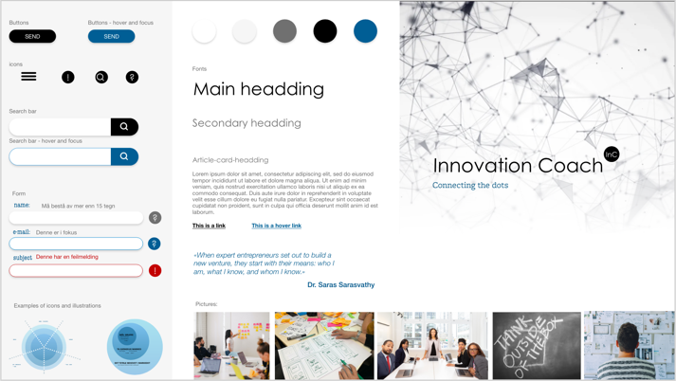 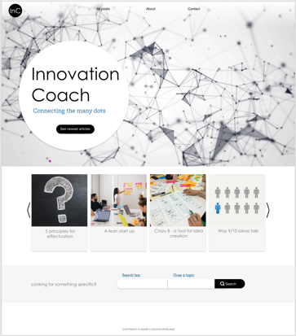 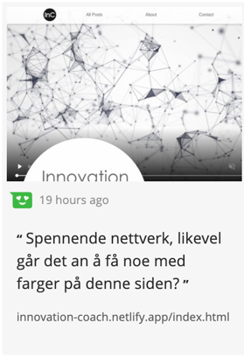

*Style tile, design of home-page and Hotjar- feedback on lack of color*

### Colors

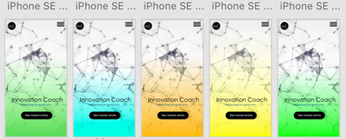Still the page lacked colors. And after I had tried to get color in by changing the color of the text, I quickly found out that contrast requirements against a white background make it difficult to find a fresh color. Therefore, I quickly switched to changing colors on different backgrounds such as buttons and the heading on the home 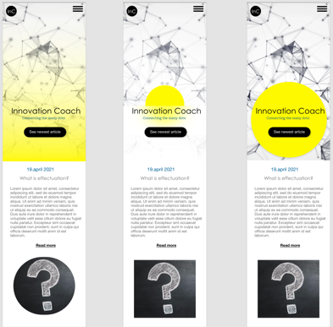page. One of the users mentioned post-it notes that are widely used in processes and methodologies when it comes to innovation. This gave me the desire to use a color that tended to neon and which then gave a fresh breath. By working with both mobile and desktop design in parallel, I came up with a gradient to bring the color into the main page. The feedback on the yellow color was a bit mixed at first, as one of my nurse-users mentioned that yellow was the infectious color and that she who currently works with covid patients got a little itchy when she saw the color. A fellow student also mentioned that he was unsure of the yellow. He also did not like the video in the background. To accommodate these views, I tested various other colors and asked the test users which alternative they liked best. Based on good feedback from other users, I chose to disregard these two views. The nurse is also in a unique situation and is not representative of her association. When it comes to my fellow student´s desire for a still picture in the background, I must anyway make it possible to pause the video in terms of WCAG. (nevne “reduced movement” fra os-et?)

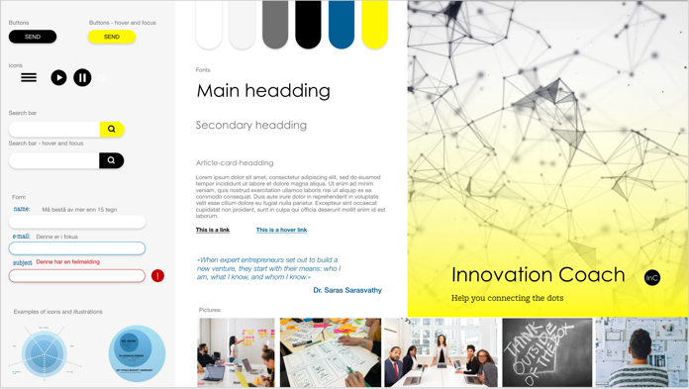 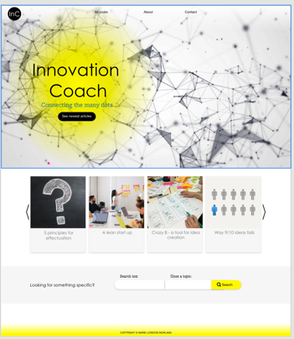

*Style tile, design of homepage and feedback on color-choice*

### Navigation and Layout

The only change in the navigation is that in the beginning I also had a collection page called "Tools and links" which should contain tools such as various canvases and templates and useful links to websites around topics. But since I received feedback that one did not necessarily know how to use the tools, and how this should be combined with search, I decided to remove the page and rather treat the tools as topics in the posts.

HotJar

Hotjar is a great tool that provides surveys, heatmaps, and recordings to show how users interact with your site and what they click on, where they hover etc... But as with all quantitative surveys, they are most valuable with a large quantity of participants. With little time to collect data, I published my page to fellow students, friends and family. While this gave me a lot of clicks and page views, I guess it also affected the data I got in the sense that they might not mirror the behavior of “real users that want to read about innovation and entrepreneurship”. Can´t really blame them as much of the text is lorem ipsum, but it seems as some of my fellow students have been more curios in how I have solved different aspects on the page, than to find and read a post of interest. (i.e., some recordings showed users that went straight to the carousel clicking like mad, resized the window a lot, and did not really looked at any other pages). Nevertheless, I did get some useful feedback from Hotjar as I discovered that none of the users clicked on the “exclamation mark”-buttons in my contact form. By giving the buttons a bigger hover effect, and a shadow to indicate that the button can be clicked, I saw in Hotjar recordings that more users discovered the buttons.

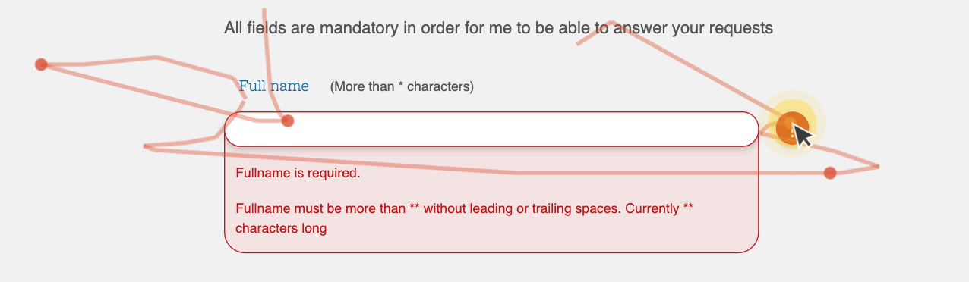

I also learned:

* Most users clicked on “All Post” in the menu as the next step after the index-page. Almost none took a short cut in to a specific post article even though they clicked on the buttons for the carousel.
* That surprisingly many users actually read the text about me. And that they choose the text about me over the text about the purpose of the blog even though they would need to scroll down the page.
* 68% scrolls down to the bottom of my home-page on desktop. On a mobile phone 50% of my users does the same. Det synes jeg i utgangspunktet er veldig bra! På en annen side kan dette være farget av at medstudentene vet det skal være en karusell på hompage og lette etter den for å se på funksjonaliteten. Annen brukertesting senere viste at det ikke nødvendigvis var intuitivt at homepage inneholdt så mye mer enn en CTA-button og en menu.

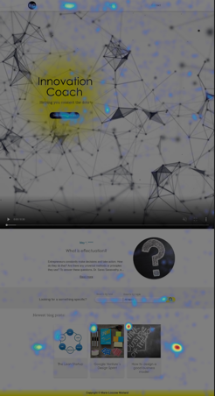 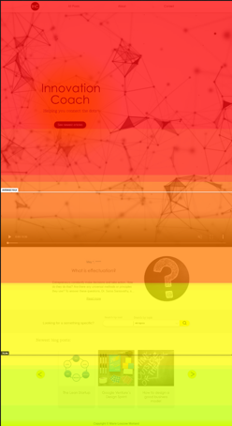

Findings and solutions

### Theme change

Once again, I have changed the look of the website in search of an innovative design. The choice fell on putting an abstract illustrative video in the background on the main page to create an atmosphere for creativity and development. I thought it was a lot of effect for little effort to put in such a video, as it did not look so difficult when I studied the code for the Mesh community. On the other hand, it turned out that it was not as easy to get safari to automatically play the video as you opened the page. There are also some features such as being able to press pause, which must be in place and which takes longer to encode than to insert the video itself.

### Colors

After testing many different colors on my users and seeing which options got the best response, I ended up with a bright yellow. With a gradient, it gave associations to the expression "a bright idea" and was described as fresh, brave and fun. The color is used on small surfaces on backgrounds to meet contract requirements and is a small splash of color that is repeated a bit here and there. I also had this color on the footer to create a splash of color at the very bottom, but this was removed when I received feedback from two users that a rather unimportant footer took a little too much attention despite the lack of content.

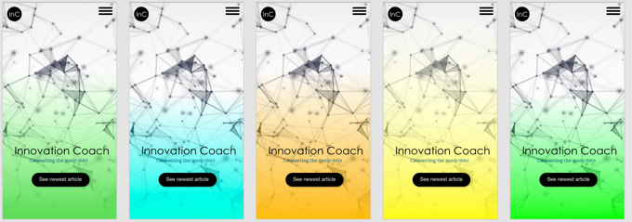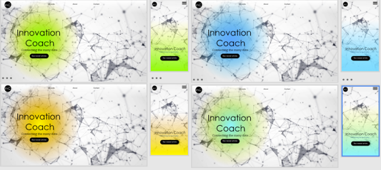

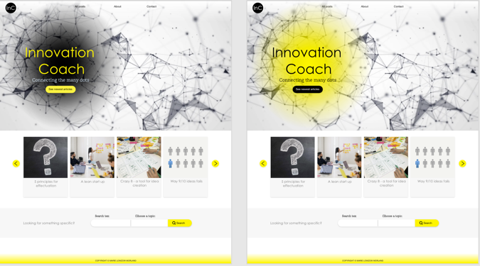

*Testing different colors on the design*

### Contact form verbose

Form is attempted built after reading from at uutilsynet that there is an advantage both with a summary of errors, located over form, by mistake after a user clicks the submit button. In addition, it is said that it is an advantage to have an error message per item, which explains to the user what needs to be done to correct it.

(https: //www.uutilsynet.no/wcag-standarden/skjema/38?)

At the same time, it is nice to prevent the user from making a mistake in the first place, so I have tried to follow a technique for this that was mentioned in w3c to give an error message when the user moves away from an input field:

https: //www.w3.org/WAI/tutorials/forms/ notifications /

Here I became acquainted with aria-live = "assertive", which I add to the error message on focus change so that a screen reader should read this aloud before reading anything else.

Early feedback from graphic users said that it felt a bit repetitive with visible error messages per field while they filled in, so I hid the text for sight behind a button, while leaving it available to screen readers. Thus, the button has strictly no function for those who use screen readers and was consequently named: "Toggle visual error message."

The challenge is to find a way to signal that this button does not change anything for the screen reader, but only graphically. I considered aria-expanded to mark whether it was selected or not, but then I would probably as a screen reader user expect a change for me as well.

### Redesign dom order (search in top, showing previous search)

One user said it was confusing to place the search box as he was unsure if all the content on the page or just the content below the search box was a result of his search. To make it more readable and intuitive, I moved the search box to the top of the allPost page

### Empty state (no search hit)

Through user testing, it quickly emerged that I had completely forgotten to have an idea of what would meet the user if you did not get a hit on your search. A little embarrassing, but nice to do something with when I first realized it.

### Don’t repeat first post in carousel

The first post "What is effectuation" was shown both as a separate post at the very top as the latest post and in the carousel. This became somewhat repetitive. At the same time, there were several who liked that the very latest item ended up in a separate section above the carousel. Thus, this post was removed from the carousel while

### Post summary on each post on top (user didn’t find search keywords)

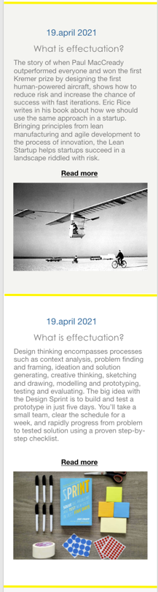After a user tested the search function, I received feedback that it did not work. The user had searched for "invest" and then clicked on one of the articles that appeared. Then he had searched for the word in the text and not found it. It turned out that the word appeared in the introductory text on the allPost page and I quickly realized that the same text should appear at the top of the article as an introduction.

### Post layout on mobile

I received feedback that the headline and image were a little too little information to assess whether the article was interesting. Thus, I changed the layout of a post and showed parts of the preface to the article on the allPosts page also on the mobile. I also received feedback that it was difficult to distinguish between the posts on mobile and that now that you scrolled quickly through many posts, you had problems assessing where the image belonged. To make a clearer distinction between the posts, I added a yellow line between the posts on the mobile layout.

*Design of posts displayed in allPosts on mobile before and after iteration.*

# Accessibility

Why all the effort

As a front-end developer, I want to create good user experiences, and it is important to me that I do not exclude anyone. Accessibility is personally something that engages me as I want to contribute to inclusion and not discrimination. That the site becomes legal according to Norwegian law is fine, but is more of a minimum requirement, as it is important to me that the user experience for someone who is blind, for example, should not be any worse than for someone who sees even if the experiences will be different. User-oriented design and development is exciting, and perhaps even more challenging when the user experience for a user group differs greatly from my own experience. Therefore, I will use this project as an opportunity to gain a greater user understanding within the topic of accessibility.

To learn what are best practices and how I can ensure good accessibility on my site, I have done the following:

* Talked to the UU-tilsynet
* Read the UU-tilsynet´s website for tips on good solutions
* Sent email to Blindeforbundet in hopes of recruiting user testers
* Read at www.w3c.com
* Listened to the podcast "Universelt utformet" while I'm on my way to pick up at the kindergarten or while make dinner
* Read blogs about accessibility
  + https://inclusive-components.design/cards/?fbclid=IwAR2jWc4034p3ZZIVav69pPVMDzD1d-G4U55YwC85D8UPcLMmZh5oRPxzM9E
  + https://axesslab.com/alt-texts/?fbclid=IwAR0AWDbFT2RJP44W14mJNaaWiN3jUkbZ_F82KFktqGFFT_gUM6w5o_LCK58
* Engaged in a forum on facebook where I have used my page as a case for discussion about best practice
* Look for new test users with disabilities

Testing:

### Testing with users

User testing is necessary for websites to work well. People with different backgrounds and needs need to test the site to make it user-friendly for everyone. Finding and conducting tests with new user groups has been both challenging, useful and exciting. The UU Authority recommends finding test users who represent several user groups with different challenges and needs. It can be:

* blind
* visually impaired
* mobility impaired, especially disability in the arms
* people with reading and writing difficulties, such as dyslexia
* hearing impaired
* people with cognitive impairment or impaired perception

I am missing a good number of these users in my testing. But I have managed to recruit someone:

* one who is blind
* two with dyslexia
* one who never remembers his glasses

### Et bilde som inneholder tekst Automatisk generert beskrivelseTesting with tools

To test the site, I have used Wave and Google lighthouse to get feedback on my code. I have done this regularly throughout the project and tried to pick up problems at an early stage. Mostly this has been helpful feedback, but I responded to Google Lighthouse's feedback on my "read more" links. I can understand that if you read a list of links with a screen reader and the whole list consists of repeated "read more" is not very inspiring and explanatory. But since an aria label has been added, they can still read a good description on the link. This is mentioned as a suggestion for a good solution in such cases at www.w3.org. A little annoyed that lighthouse had not picked this up, I sent a message on github to Google Lighthouse.

I have also used the keyboard and the screen reader VoiceOver to test how the page is experienced when one is dependent on such tools to use the page. I must admit that I struggled a bit to navigate, and am no expert at using it. Nevertheless, it has been instructive and useful. Among other things, it is clear that there is a lot of unnecessary repetition when you constantly have to get through the menu-list every time you go to a page. Now I do not have the longest content in menu, but when I discovered the concept of skiplink, I got excited, and had to try to make one.

### Engaging a facebook forum

To get feedback on Accessibility, I posted my page on a forum for accessibility enthusiasts on Facebook. This resulted in an exciting discussion about best practices on various topics with my project as a case. Here I learned a lot from experts and got several good tips for improvements that were not picked up by tools like Wave and Google Lighthouse. Fun and inspiring to see the engagement and that they took the time to test the page with screen reader and look at my code. This weekend with submission, I also got a new blind test user who set aside time to review the page and make comments. All in all, I got feedback that a lot was good, and that what they came up with was mostly small picks. One of the participants put it this way: *"I would say that your page is accessible, but that it can probably be smoother."* I take that as a big compliment and a encouragement to continue my engagement for the subject.

## Findings and solutions

### Skiplinks

The concept is to create shortcuts down the page for someone who uses tabs to navigate. Just like you can press "skip intro" on a series on Nettflix, this button can skip the list of menu options. The button only becomes visible if you use tabs to focus, and has a tab index that makes it the first thing that appears. This allows you to skip the menu and go straight to the main content or (for those pages where it is relevant) to the search bar.

### «Reduced motion» (not impl yet)

As some people struggle to concentrate or have dyslexia where it is more than enough to keep control of the letters, it will be nice for some to be able to pause the animation on the homepage. At the same time, I think a play / pause button does not fit into the design visually. That's why I've added that you can tap the video to pause it. User testing shows that users find this feature easily even if it is not very visible. For someone navigating with a keyboard, on the other hand, a visible pause / play button appears when you use tabs to change focus.

Some people check in their systems that they want reduced movement. For example, there may be people with crystal melanoma, difficulty concentrating or vestibular motion disorders who do not tolerate movement and animations very well. The prefers-reduced-motion CSS media feature is used to detect if the user has requested that the system minimize the amount of non-essential motion it uses.

https://developer.mozilla.org/en-US/docs/Web/CSS/@media/prefers-reduced-motion

### Long anchor-tags

Before, I had the whole post as a link in the All-post page. I received feedback that the link was very long for a screen reader and that it became difficult to get an overview of the topics when so much was to be read. "Read more" was probably enough as a link but should have an aria label such as. "Read more about Google Venture's Design Sprint", so that the various link can be distinguished from each other for a screen reader user.

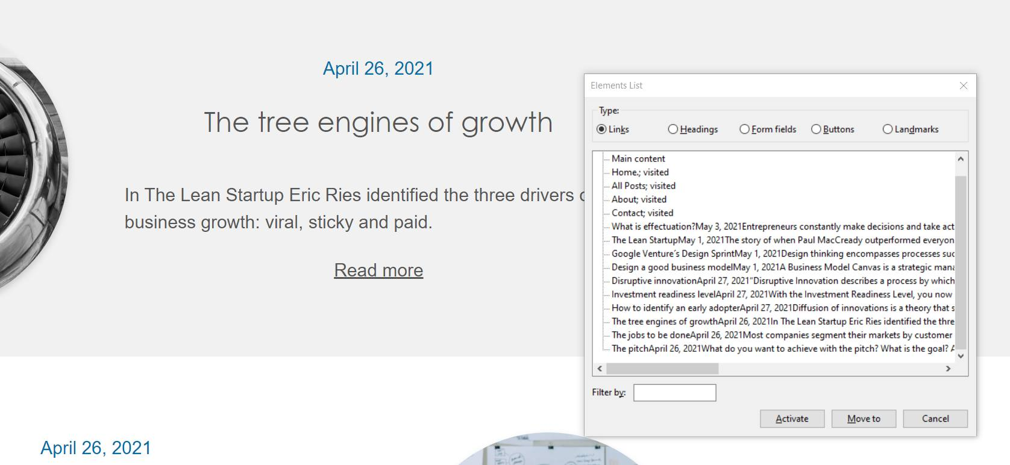

Colors

WCAG 2.1 requires that non-textual content has a contrast ratio of at least 3:1 to adjacent color (s). The cursor that shows which page is active on the page can be difficult for people with impaired vision to spot. WCAG 2.1 contains future requirements that do not apply today, a recommendation is nevertheless to start getting acquainted with what is to come. I did like to have the cursor bright yellow, but to meet upcoming requirements, I have changed the color to black to match the loader and homepage video

### Aria-current

I got a tip on Facebook that aria-current = page be nice to have on the cursor of the current active page. Aria-current tells the user that there is a cursor here that tells you what page you are on.

### Aria-labels

Aria-labels is used many places on the project:

* On some buttons
* On input fields
* On the skiplink
* On links

For example: I have added an aria label to the "read more" links on the allPosts page so that a screen reader, for example, will read "read more about The lean Startup" in the article about Lean startup and Eric Rice.

### 

### Aria-live (carousel and contact form)

As mentioned when describing the carousel it was annoying that one had to tab back every time you pressed the button to view more posts. To make it easier for a screen reader user to get an overview of the new content in the carousel without having to tab back all the time, I therefore added an aria-live attribute to the carousel content so that it is read out without the user having to change focus away from the button. Aria-live is also used in the contact form so the screen reader will read out the error message if you tab before filling in the input correctly.

### Menu close after list (not implemented yet?))

I got feedback that it was tricky to close the hamburger menu with screen reader, had to navigate back through the menu to close it. Therefore, it was recommended to make a close button at the end of the menu. CSS and where it is placed is not so important, as long as it is last in the tabindex

### Modal should not tab outside, and be keyboard accessible

After listening to the poscast "Universelt utformet", I found that my modal was a little too simple as I had coded it. When you are in a modal, you should not be able to move around the focus in the background. Focus should remain within the modal, and it should be possible to close the modal with the keyboard, either by selecting the close button or pressing «escape». This also prevents screen readers from reading the content behind the modal. If not, it can quickly become very confusing for the user.

### HTML structure

I have tried to be aware of the order in which the screen reader reads out the content and that what it reads should be experienced as exciting. This has meant that I have, for example, written the date for each entry under the heading, but used CSS to place it visually. I thought the same way about the carousel's post-cards where I first made sure that Voiceover read out the headlines in the post-card before the picture is presented.

### Alt-text

At frist I made sure that every image had an alt-text. But than I read a blog written by a blind man about how he preferd alt-text being used, and that it can be experienced as annoying in some cases. Listing of articles was mentioned as an example. Since the pictures are first and foremost decorative in the lists, I therefore chose to go for a blank alt in card and all-posts, but describe the pictures when you are in an article. On another hand: As I have discussed the issue with others one can on another side think “what if someone talking about the page and saying "Find that blog post with a picture of an old plane"?” I guess the best solution is to consult with real users (mulitble) although I have a feeling that their opinions are also divided. One solution is to go back to have alt-text again as many may want to have it there for examples as mentioned above (where some describe content based on an image). And as long as the image is placed after the link text in the DOM, it is easy for the user to skip the picture.

Another solution I have thought of that may also be of benefit to other user groups is also to create two different display modes to choose from:

* One with pictures
* One with just headers and text

In a user test, it was mentioned that the images might be of less interest, especially when searching for a specific topic. Then you experienced that the pictures took up a lot of space. As a possible solution, he suggested having different list views. In a blog with professional articles, the written content is much more important than the picture. That’s different from what might have been the case if the blog had been a food blog.

### Headings

I have also learned to be aware of my headings. On one of the previous designs I had "innovation coach" as a kind of visual and decorative headline in the header. Almost as an alternative to a logo. But for someone who uses a screen reader, it will be terribly boring to read if the main headline on all pages was the same. The thought of reading a book where all the chapters had the same headline sounds ridiculous, impractical when it comes to navigation, and uninspiring. Although this did not become a relevant issue at the final design, the experience has made me aware of making exciting headlines – also for a screen reader.

### Custom focus

I got tips on defining focus marking in the css code. If not, you get different and not always optimal focus marking across browsers. At first, I thought that many people where probably used to looking for focus as the default is on the browser they normally use. Therefore, I thought that it might be okay if I always had "something" that changed in focus, but that I did not take away or walk in the legs of the default behavior. But after discussing with experts in the field, I learned that Best practice is to define your own focus marking as you yourself are in control of contrast conditions and presentation across browsers. A stated participant in the discussion commented that “*Chrome's default focus marker would have failed WCAG if there were no native focus marker exceptions.”*

Last round of feedback:

## Some new fresh eyes on the site

The last week, I recruited brand new participants for user testing. In total, I have had 17 people who have tested the site and given me feedback, without counting feedback from students. (they are a slightly special user group with a different agenda)

Standing behind one of the new users while he was testing the site, gave me new insight that would be hard to get through a chat on internet. For instance, I saw that the user did not scroll down while he was at the homepage. As one cannot see the scrollbar on mac, it was nothing that indicated that there were more to see on that page. The solution I went for was to change the CTA button and add an arrow to indicate that the button would take you further down the page and that it was more to see.

At the end feedback have also been asked if the page should perhaps have a comment field under the articles as a post on subject matter may be particularly well suited to start a subject discussion that could later have raised new topics to write about in the blog. The desire and the question of getting feedback on the blog's content should appear on each individual post so that the threshold for giving feedback is lowered.

## Test with a blind user

Due to illness of the user, this test was postponed and was not completed until the Saturday before submission. I'm still glad I set aside time even though I was a little stressed about finishing this report (which is starting to get annoyingly long) and have a part on the list of things that can be improved. Gaining the experience of setting up such a user test and gaining insight into her use of websites was incredibly instructive and valuable.

The test was done online as she lives in Tromsø and I at that time was at a cabin in Tvedestrand. We used Zoom to talk and with some time we managed to share screen in oder for me to see where she was focusing while she used the screen reader on my website. It did not work as well as intended, as the screen reader sometimes removed the visual focus mark on the screen. Still, it was convenient to at least see which page she was on and what happened as she filled out the contact form. She also explained a bit about how she proceeded using a screen reader, what other tools she used and a little about her own skills contra what is possible and what you can expect from someone who uses screen reader and braille terminal in everyday life.

When she entered the site, the skiplink was the first thing she discovered, and was very positive about it. Soon after, she said it did not work, until she again came up with an "Aha! There is a list below here!" The screenreader had read out the aria label on the nav element "Skip to content" and she had thought it was a link. This led me to change the aria label on the nav element to "Skiplink Menu" and put two new aria labels on the links called "Go to main content" and “Go to search bar”. All in all, she was very happy with the skiplink and commented on the new pages that it was great to be able to jump straight to main content.

I asked her about her preferences around alt-text in the pictures on the all-posts page as this has been a topic I have been unsure of what would be the best way to solve it. Here it was clear that she was initially not very spoiled with good all-texts in the pictures, and just the fact that there was a thought about it, was more than enough for her. She thought it was nice and effective without all-text on the all-posts page and did not feel any need for more explanations of what pictures were shown there as long as it appeared on the specific post. When I put forward my thoughts on "what if someone talks about the page and says" Find that blog post with a picture of an old plane "? she laughed and thought I was over-complicating it a bit. She said that it was more up to the person she talked to to give a clearer description of the content of the article. After all, it was the content that was important, and besides, she would use the search field to find the right post instead of searching around for alt texts. She laughed and smiled when I told her that I had read a blog and learned to put a full stop at the end of an alt text so that the screen reader takes a short break when reading aloud.

When it came to alt texts in general, she suggested nrk.no as a good role model because they are short and informative. She also explained that she had two braille terminals. A long one that she had lying at home with room for 80 characters, and a shorter one of 40 characters that she could carry around and connect to more mobile devices such as mobile and laptop at the university. The braille terminal with 40 characters made her very much appreciate if alt texts and other short messages stayed within 40 characters as she then did not have to "scroll" to the next line on the braille terminal.

She orientated herself nicely and said that the page was neat and that it was easy to get to know the page and understand the navigation. On the all-post, she quickly went through all the headlines and read a few preface. She explained that she often used headlines to orient herself. Those who were a little more professional with screen readers could get lists of links and other functionality.

The search function was understandable and useful. She also thought it was nice with the page that told that there was no article with the topic she was looking for. She particularly liked the illustration text for "sad face" which she described as "cozy". One thing she mentioned as a potential for improvement was that H1 in this case could have been changed from all posts to "No results" or similar. Since I have made this H1 a screen reader only, I had forgotten this a bit as I do not see it myself.

When we came to the contact form, she became very enthusiastic, as she had filled in many bad forms before. I deliberately asked her to write something wrong in the first place. Aria-live informed her of the error and she thought it worked very well. When she deliberately pressed send with errors in the form, she expressed "Wow! This works really well! Here I get listed the errors and it takes me directly to where I have written errors! Not all forms work so well! " But when she pressed the "send" button, she became a little unsure, as her screen reader did not get the user message that the message had been sent. The solution I went for was to add role = dialogue and aria-live=assertive. Another solution is to create the message in the same way as the modal window.

All in all, she was very happy with the site. Best of all was that accessibility was clearly thought of, and that the page was easy to navigate. She met no obstacles and accomplished everything she wanted. The user message about the confirmed sent message was perhaps what she missed the most but emphasized that she still understood that it had probably been sent when she discovered that the form was emptied. The form otherwise was a highlight.

Future work

Although the blog has come a long way, there are several ideas and plans that were scoped out, and the blog site still has good potential for improvement. My preliminary list of things to do says:

* next / previous post buttons on each post page
* comments on post page
* alternative «all posts» layout, with local storage to remember what youd like (pictures or not)
* Menu close after list
* «reduced motion» (not impl yet)
* Fix user message for “successful message sent” to be accessible.
* Change h1 when searching for specific topics

# Conclution

All in all, I would say that the goal "to put into practice the skills learned over your first year of studies" has been achieved in many ways. In addition, the project has led to new knowledge and new experiences. Especially within accessibility, which I have chosen to give an extra extra on this project. This focus has been at the expense of time and capacity to complete all the functions and tasks that were listed as optional level 2 tasks.

During this project I have had several discussions with myself, users and others on a lot of issues. This is a shortlist:

* What is an innovative design on a webpage?
* Should I use time and focus on more functions vs accessibility
* File structure ( i.e two «post.js»)
* Alt text for images in carousel or not
* How to solve functionality like search, carousel and “more posts”-button.
* What should be page headers?
* Code structure/design (when should something live in its own js/css-file(?))
  + separated user feedback and form js file
  + header for homepage vs other pages
    - reuse code vs. duplication
  + general function vs specific
    - e.i I can only have carousel on a page, while I can have multiple forms on same page. Yet I only have one…
* css selectors
  + e.i. I went from one single «nav» to two when making the skiplink, I got, problems in styling and js selectors that relied on selection «nav»

## Key learnings

### User Testing

Once again I sit with the experience of that user feedback have been fundamental to develop a good site. It is impossible to find all the possibilities for improvement yourself. And the more test users you have the better. It has been challenging to find users with various disabilities to test the site. In retrospect, this is something I would have liked to have started with earlier. Especially since unforeseen things like illness made the test run a little late in the process. Although there could be little time to make any potential major changes before delivery, the experience was still valuable enough that I was glad that I set aside time and completed the test. User testing is all in all very fun and inspiring and my experience is that you get the best result when you invite users to co-create the site with you. Now and then it is also good to get some fresh eyes on the project, so it is also nice and valuable if not all users have been involved in the whole process but that they have entered the project along the way.

### Technical solutions

I think I have found a good way to structure code and folders in Visual studio. Although there is a total of many lines of code, the system makes it easy for me to find the code that is relevant when I, for example, have to find the solution on a bug. On the other hand, there is always a discussion about whether something should have its own file, or whether it should be coded on the page-specific page. Good names on the files are also important and may not be perfect in this project.

The fact that I had already worked with similar solutions to the functional challenges in previous assignments, resulted in me saving a lot of time when I had to find out functions such as form validation and carousel. For every time I have created for example, a form validation, I have made adjustments and tried to improve the code to the better.

A good development environment makes it much easier to work efficiently. Plugins in Visual Studio such as Live server and es6 template, have been good to have. es6-template makes my html code colored and thus easier to read. Live server has allowed me to see the consequences of my code live. By connecting my mobile to the same network, I also got tested with my mobile in the same way. There is something about checking printing surfaces and testing with a physical mobile. I think it provides more than just reducing the screen size in devtools.

### Accessibility

Wow, there is a lot to learn about in accessibility! Also, here the users and experts disagree on what is the best solutions. I want to highlight what in many ways was the conclusion of our discussion on Facebook: *“WCAG compliance is often too little / too poor. I'm really looking forward to the accessibility declaration becoming standard.”* I got early signals from tools like Google lighthouse and Wave that the code was good according to WCAG. Nevertheless, I have experienced that WCAG as a checklist is not enough to ensure a good user experience for everyone. A site with good accessibility and a site with good WCAG compliance are not necessarily the same. As another user said: *“then one must look up and aim for accessibility rather than the pursuit of compliance”*

# Referance:

## Accessibility

<https://www.uutilsynet.no/webdirektivet-wad/wcag-21-standarden/140>

<https://www.uutilsynet.no/wcag-standarden/losningsforslag-nettsider/36>

<https://www.uutilsynet.no/regelverk/brukertesting-med-funksjonshemmede/193>

<https://axesslab.com/alt-texts/?fbclid=IwAR0AWDbFT2RJP44W14mJNaaWiN3jUkbZ_F82KFktqGFFT_gUM6w5o_LCK58>

<https://developer.mozilla.org/en-US/docs/Web/CSS/@media/prefers-reduced-motion>

<https://inclusive-components.design/cards/?fbclid=IwAR2jWc4034p3ZZIVav69pPVMDzD1d-G4U55YwC85D8UPcLMmZh5oRPxzM9E>

<https://www.w3.org/TR/wai-aria-practices/examples/menu-button/menu-button-links.html>

<https://www.uutilsynet.no/wcag-standarden/skjema/38fbclid=IwAR0G5EhFdd1svhKcRt6aEwCU6wmX8w9P27zctYxaBZ8A55onRN0FYXXlJqo>

<https://www.w3.org/WAI/tutorials/forms/notifications/>

<https://stackoverflow.com/questions/40555111/what-is-the-best-way-to-use-a-background-image-on-a-div-yet-remain-accessible>

<https://stackoverflow.com/questions/52783375/anchor-with-href-not-taking-focus-in-safari-even-with-all-accessibility-keyboard>

<https://www.webassign.net/manual/student_guide/t_a_osx_tab_config.htm>

<https://developer.mozilla.org/en-US/docs/Web/API/Window/innerHeight>

<https://developer.mozilla.org/en-US/docs/Web/Accessibility/ARIA/ARIA_Techniques/Using_the_aria-hidden_attribute>

<https://developer.mozilla.org/en-US/docs/Web/Accessibility/ARIA/ARIA_Live_Regions>

<https://www.aditus.io/aria/aria-current/>

## Bugs and function

<https://stackoverflow.com/questions/41512200/how-do-some-websites-play-video-inline-in-ios-safari> (safari på mobil ville ikke autospill eller la file være i line uten)

<https://help.hotjar.com/hc/en-us/articles/360046960654-Why-does-my-Heatmap-screenshot-look-cut-off-the-wrong-size->

<https://developer.mozilla.org/en-US/docs/Web/JavaScript/Reference/Global_Objects/Object/entries> (hvordan gå gjennom et objekt)

<https://developer.mozilla.org/en-US/docs/Web/API/Node/insertBefore>

<https://uxdesign.cc/how-to-trap-focus-inside-modal-to-make-it-ada-compliant-6a50f9a70700>

<https://stackoverflow.com/questions/50178419/how-can-restrict-the-tab-key-press-only-within-the-modal-popup-when-its-open>

<https://medium.com/@mahesh_joshi/wordpress-contact-form-7-rest-api-endpoints-bf45907b571c>

<https://stackoverflow.com/questions/21044798/how-to-use-formdata-for-ajax-file-upload>

<https://developer.mozilla.org/en-US/docs/Web/JavaScript/Reference/Global_Objects/Array/shift>

<https://css-tricks.com/bold-on-hover-without-the-layout-shift/>

Det var utfordrende å få nav bar til å stå stille når hover ble bold. Lagde en kopi av teksten i bold som var hidden slik at plassen alt var satt

Sticky fungerer ikke slik som jeg vil:

<https://developer.mozilla.org/en-US/docs/Web/CSS/position>

<https://www.w3schools.com/howto/howto_js_navbar_sticky.asp>

<https://css-tricks.com/line-clampin/>

<https://contactform7.com/getting-started-with-contact-form-7/>

## Pictures:

<https://unsplash.com/photos/onLbXleIkds>

Photo by [Isaac Benhesed](https://unsplash.com/@isaacbenhesed?utm_source=unsplash&utm_medium=referral&utm_content=creditCopyText) on [Unsplash](https://unsplash.com/?utm_source=unsplash&utm_medium=referral&utm_content=creditCopyText)

<https://mycolor.space/gradient?ori=to+bottom&hex=%2354A4EA&hex2=%23006093&sub=>

<https://unsplash.com/photos/Cp-b69OOyN4>

Photo by [Jo Szczepanska](https://unsplash.com/@joszczepanska?utm_source=unsplash&utm_medium=referral&utm_content=creditCopyText) on [Unsplash](https://unsplash.com/?utm_source=unsplash&utm_medium=referral&utm_content=creditCopyText)

<https://unsplash.com/photos/Oalh2MojUuk>

Photo by [Leon](https://unsplash.com/@myleon?utm_source=unsplash&utm_medium=referral&utm_content=creditCopyText) on [Unsplash](https://unsplash.com/?utm_source=unsplash&utm_medium=referral&utm_content=creditCopyText)

<https://unsplash.com/photos/wusOJ-2uY6w>

Photo by [Amélie Mourichon](https://unsplash.com/@amayli?utm_source=unsplash&utm_medium=referral&utm_content=creditCopyText) on [Unsplash](https://unsplash.com/?utm_source=unsplash&utm_medium=referral&utm_content=creditCopyText)

<https://unsplash.com/photos/IZ01rjX0XQA>

Photo by [Thomas Vimare](https://unsplash.com/@vimarethomas?utm_source=unsplash&utm_medium=referral&utm_content=creditCopyText) on [Unsplash](https://unsplash.com/?utm_source=unsplash&utm_medium=referral&utm_content=creditCopyText)

<https://unsplash.com/photos/qC2n6RQU4Vw>

Photo by [UX Indonesia](https://unsplash.com/@uxindo?utm_source=unsplash&utm_medium=referral&utm_content=creditCopyText) on [Unsplash](https://unsplash.com/s/photos/ui-design?utm_source=unsplash&utm_medium=referral&utm_content=creditCopyText)

<https://www.pexels.com/nb-no/bilde/sprak-sitat-kritt-innovasjon-6375/>

<https://www.pexels.com/nb-no/bilde/avgifter-euro-fond-gris-9660/>

<https://www.pexels.com/nb-no/bilde/samarbeid-forhold-tilkobling-forbindelse-3184433/>

<https://www.pexels.com/nb-no/bilde/handtrykk-samarbeid-tilkobling-forbindelse-3184423/>

<https://www.pexels.com/nb-no/bilde/forvirret-rom-test-forskning-212286/>

<https://www.pexels.com/nb-no/bilde/flyplass-fly-luftfart-motor-459402/>

<https://www.pexels.com/nb-no/bilde/sporsmal-hjelp-nysgjerrig-symbol-356079/>

<https://www.pexels.com/nb-no/bilde/inspirasjon-teknologi-lyspaere-ide-3758105/>

Video:

<https://pixabay.com/no/videos/nettverk-koble-internett-abstrakt-45961/>